Table of Contents

1. | Title of Project | 1
2. | Introduction & Objective | 2-3
3. | Problem Definitions | 4
4 | Existing System, Proposed work and Scope of the work | 5-7
4. | System development lifecycle | 8
5. | System analysis | 9
6. | Feasibility Study | 10-11
7. | SE paradigm applied | 11
8. | Design and features | 12-15
9. | Context Diagram | 16
10. | DFD, Database tables | 17-19
11. | Tool/Platform Requirement | 20
12. | Proposed Enhancement and Abbreviation | 21-22
13. | Reference And Bibliography | 23

Title of the project

Rmlau Gyansthal

Introduction
We are very glad to introduce our project “Rmlau Gyansthal”. As a student of Rmlau we face some problems related to content of collage subject, content, syllabus and PYQ in one place .This site will help university students to collect these data from one place.
A Rmlau Gyansthal is a Learning Websites that provides the student of Rmlau Campus to access E-contents and PYQ. This website helps to learn and practice.

Objective
This website would help to keep learning contents, PYQs, Syllabus in one place. It provides placements related information of all department and student performs of all subject using their result.
Every departments students would be able to access these data after registration. It becomes very easy to manage and customized learning contents on their requirement.

Problem Definition

As a student when we want to do self study we need a book or contents from internet. But many of time when we search for any particular topics we not found a satisfied solution or answer from different websites.
Now a day there are many e- learning websites but they not provide all the contents related to our collage subjects. We search these content on different websites many times to find a satisfied and
Right contents.
In the preparation for semester exam we search PYQ to understand exams pattern and to solve these papers but that time we find PYQs after many difficulties because seniors not keep that papers for one semester or for one year.
The main objective of Rmlau Gyansthal is to help the Rmlau students to learn and study. This project should support multi user environment. This is designed to solve the Student problem according to their requirement through Discussion forum. This system should be able to handle extremely large volumes of data
The following details are involved in this Rmlau Gyansthal,
- Admin/Open and Manage E- contents/View Students problem.
- Discussion forum /to post audio, video or image of their problem

Existing System

- Existing system mostly contains Only carry technical content
- Existing system have lack of discussion forum to solve generated problems.
- Existing system keep most of the data are paid or premium.
- Existing system not contains learning contents of any particular collage or university.

Proposed work
In order to make the site dynamic and more interactive we have tried to include a database link to our official website The proposed Rmlau Gyansthal is a Rmlau Learning website which provides all the study material which are needed in study as pr student requirement. This JAVA project will help to all the student and teacher to make learning more easier. This site will also help the admin to view and manage all the e-contents . We have developed our project using the three tier architecture. Thus the site becomes more interactive and accessible to students.
- The aim of proposed system is to Reduce the problem of student and provide all the study material in one place.
- The proposed system can overcome all the limitations of the existing system.
- The system provides proper security and reduces the manual work.
- It is useful to store E-contents, syllabus, PYQs and placement information of any department accurately.
- We can easily handle data efficiently & effectively.
- With the help of this system student can see all the contents about their subject only at any time efficiently.

Scope of the work

As this is learning websites it can be used by a the students of Rmlau students. The main goal of this websites is to provide very reliable & efficient service to the students at any time & any location.

This system will cover mainly two Modules, i.e.
1.Admin.
2.Student

- Admin Module will cover Seven Submodules

a. Add Syllabus
b. Add E-contents.
c. Add PYQ.
d. View Registered Student.
e. View Contac us details.
f. View Students feedback.
g. Manage Discussion forum.

- Student will cover 10 Submodules

- Department Details.
- Syllabus.
- E-contents
- PYQs.
- Placement Details.
- feedback.
- Registration/login.
- Practice.
- Discussion Forum
- Quiz

Detail information about system modules

1. Departments Details:
It mainly contains Department related information.
As a submodules.
i)about department Faculty
ii)syllabus
iii) E-contents of subjects,
iv)PYQs,
v)Students results
vi)Placement details of Department.
2. feedback:
It is mainly used to get feedback from student and teacher about this websites and some advise to make this sites more Efficient.
3.Registration/login.:
It provide a form to get student information through registration and provides access to login in this websites to access their requirements.
4. Practice:
This section provide students some exercise or question to practice them. And its provide Cs Students Dynamic console to practice codes.
5. Discussion Forum:
It is like a facebook or instagram but it is used for post their problem in the form of images ,video or text .On which any one can give their suggestion related to the post or problems.
6.Quiz:
It is mainly used to practice their subjects in the form quiz.it makes study more easy and simple.
System Development Life Cycle

The System Development Life Cycle (SDLC), or Software Development Process in systems engineering, information systems, and software engineering, is a process of creating or altering information systems, and the models and methodologies that people used to develop these systems. In software engineering, the SDLC concept underpins many kinds of software development methodologies. These methodologies form the framework for planning and controlling the creation of an information system the software development process.

Broadly, following are the different activities to be considered while defining the system development life cycle for the said project:
- Problem Definition.
- System Analysis.
- Study of Existing system.
- Drawback of the Existing System.
- Proposed System.
- System Requirement study.
- Data Flow Analysis.
- Feasibility study.
- System Design.
- Input Design.
- Updating.
- Query/Report Design.
- Administration.
- Testing.
- Implementation.
- Maintenance.

System Analysis
System analysis is the main features of the software development. It can be said that it is the heart of any of the system. The analysis needs an expert supervision and person should be minimum System analysis with experience of 3 to 5 years. One can use Analysis tools to analyze the system.
Some of the tools we have used to analyze the problem is given below,

Analysis Tools
Data Collection Tools:
In order to get the information for our proposed application we approached the Textbooks and Websites and some Experts, and collected the information related to our application. This was necessary to make general software, which can be used by any Business/Organization.

Charting Tools:
The graphical Representation of system and activities help us to understand the minor problems and the flow of information very easily, which can become very helpful in analysis as well as to generated the new systems requirement. Graphical representation is always better than normal text. In order to understand the flow of information in the system the Data Flow Diagram plays a very important role. E-R Diagram are used to convert the entities and relationship in the relational tables.

Dictionary Tool :
This tool helps us to maintain and record the data & description of system element through data items, Processes and data sources. This basically helps us about the information flow among various units.

Feasibility study

Feasibility Study is essential to evaluate cost & benefit of the proposed system. This is very important step because on the basis of this; system decision is taken on whether to proceed or to postpone the project or to cancel the project. Feasibility study forms the most important phase in the system development life cycle so that the people who are affected by the system benefit from the change. This involves some very crude estimates of schedules of completion of the proposed system and the cost of the system. This study ensures that the system meets the objectives of the organization before it can be approved for development. It also involves the study of different risks involved in developing the system.
The major areas to consider while determining the feasibility of a system are:-
Technical Feasibility:

The technical feasibility study always focuses on the existing computer hardware, software and personal. This also includes need for more hardware, software or personal and possibility of procuring or installing such facilities
Rmlau Gyansthal is a system that can work on single stand alone Pentium machine with 128 MB RAM, Hard disk drive size of 80 GB, mouse, monitor and keyboard & it also require internet connection to corresponding computer. The equipments are easily available in the market, so technically the system is very much feasible.

Economical Feasibility:

This feasibility is useful to find the system development cost and checks whether it is justifiable. The cost overheads include software and hardware maintenance cost, training costs that includes cost required for manpower, electricity, stationary etc. The proposed system will provide the right type of information at right time, and in the required format. This will save time required for decision-making and routine operations. Considering all these advantages, the cost overheads of the system are negligible. So the system is economically feasible.

Operational Feasibility :
It is also known as resource feasibility. The operation users of the system are expected to have minimum knowledge of computer. The developed system is simple to use, so that the user will be ready to operate the system. The proposed system is developed using JAVA programming language & Mysql database which is platform independent and user friendly. So the system is operationally feasible.

Software Engineering Paradigm Applied
To solve actual problems in an industry setting a software Engineer or team of Engineers must incorporate a development strategy that encompasses the process methods and tools.
A process model for software engineering is chosen based on the nature of the project and application, the methods and tools to be used and the controls and deliverables that are required.

Design
Software Design is the first of three technical activities design, coding and testing that are required to build and verifies software. The flow of information during this technical phase of the software requirement, manifested by information, functional and behavioral models feed the design step. Using one of a number of
design methods the design step produces a data design, an architectural design and a procedural design. The architectural design defines the relationship among major structural components of the programs. The procedural design transform structural component into a procedural description of the software. Source code is generated and testing is conducted to integrate and validate the software.
Software design is the process through which requirement are translated into a representation of software. From a project management point of view, Software design is conducted in two steps
- Preliminary Design
- Detail Design
Designing of this software is done with high cohesiveness i.e. there is minimum interaction between two different modules. There is no intra modular relationship between modules. Most of the modules are self-independent. At same time modules are loosely coupled i.e. inter modular relation exists.
Designing part includes its data flow diagrams, Database Tables and process logic of each and every modules, input design and output design. Input design includes input screens such as Business Login screen, Business Registration Screen, Unit Creation Screen, Unit Operator Creation Screen, Session Creation & Termination Screen.

Features

A. Admin Window:

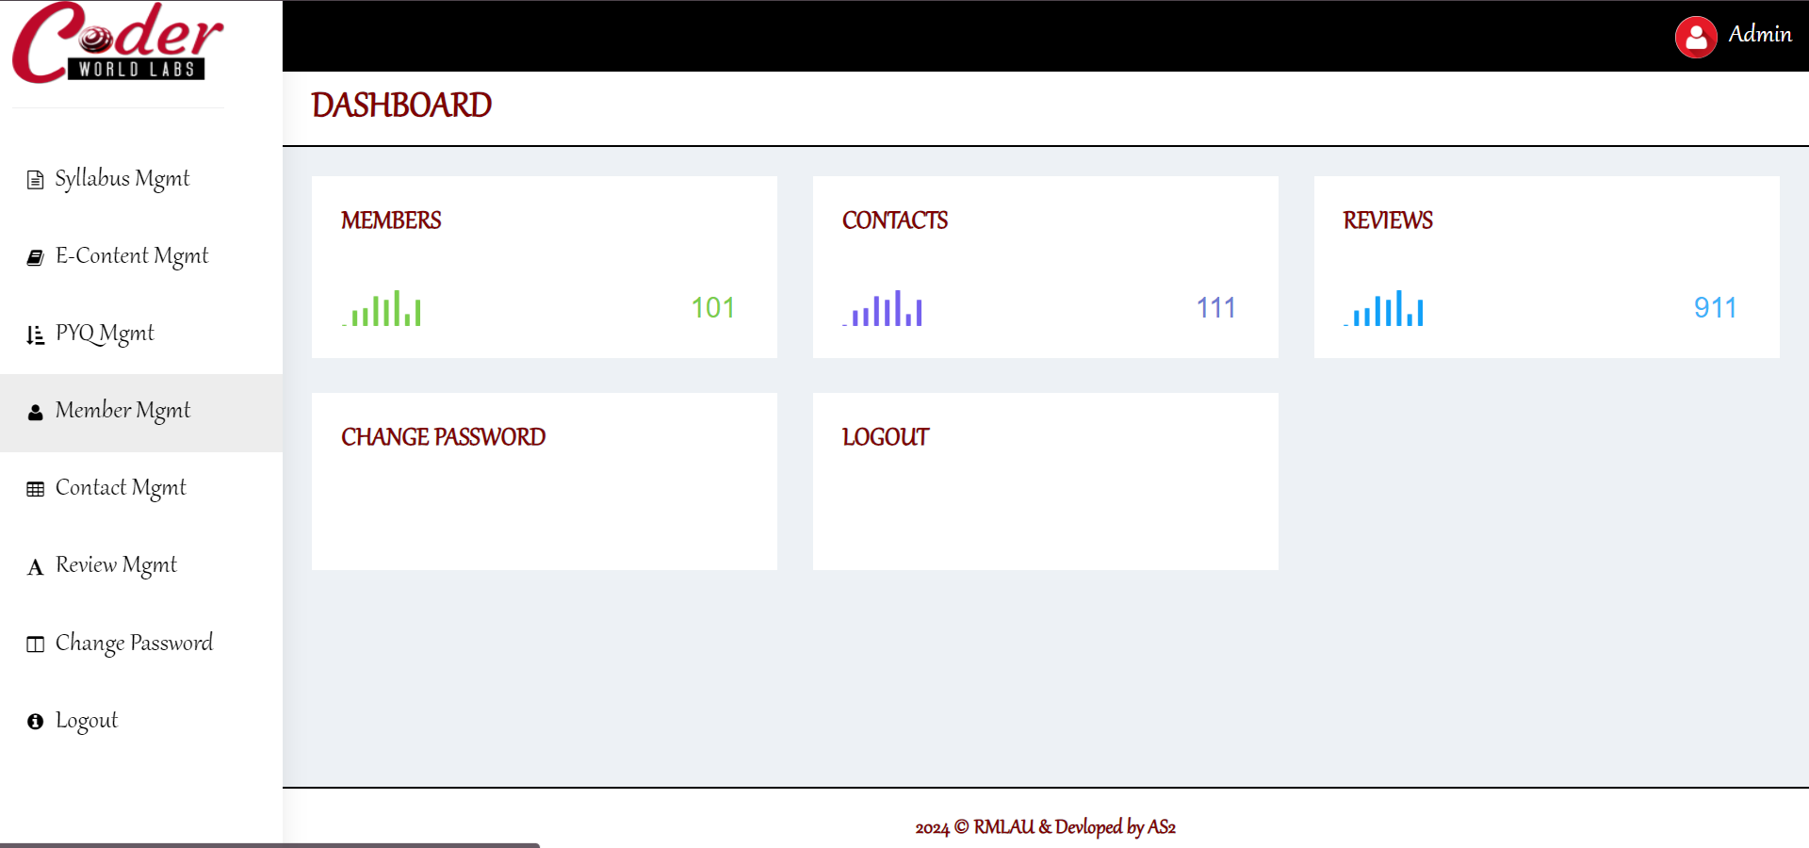

B. Student Window:

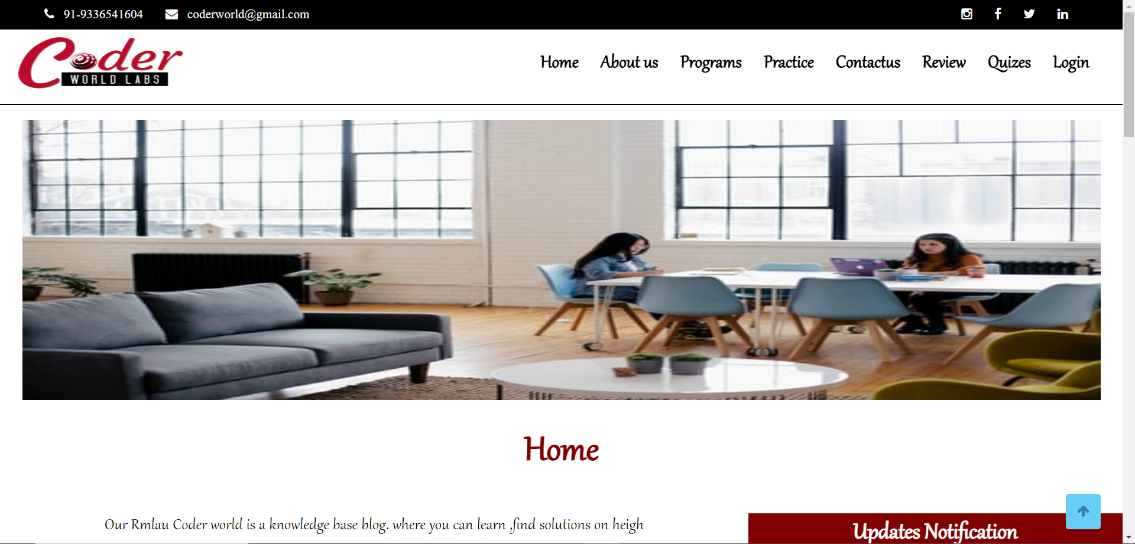

(i) Faculty:

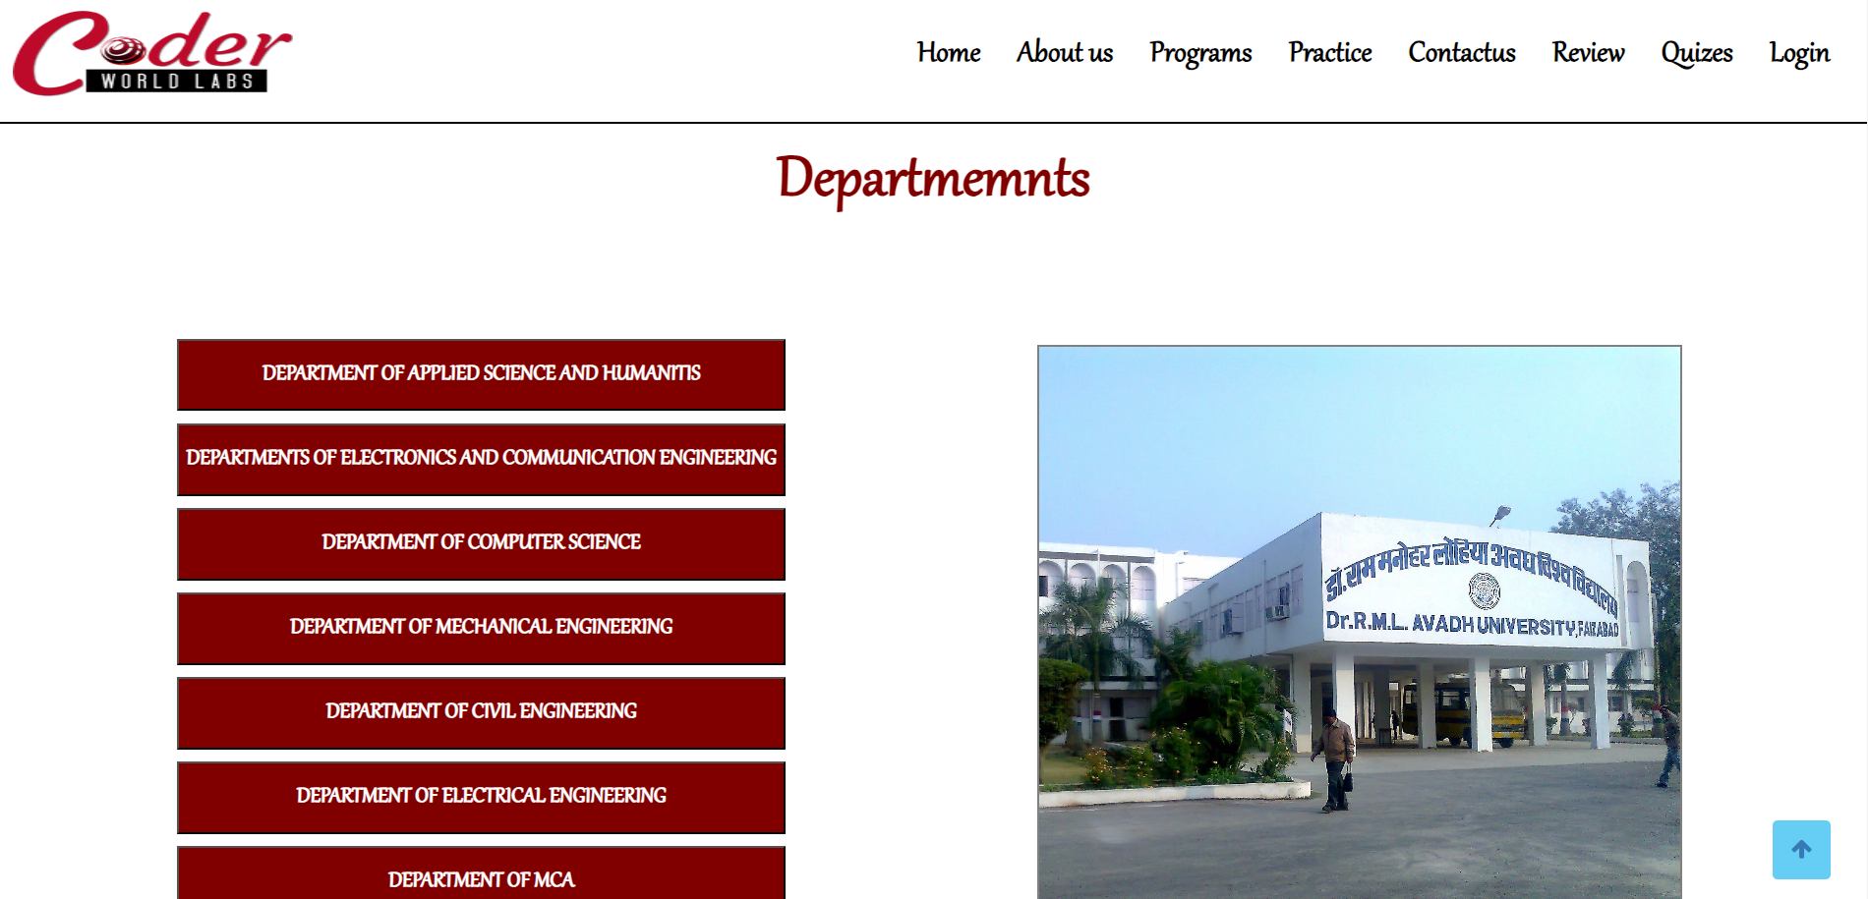

(ii) Deparments:

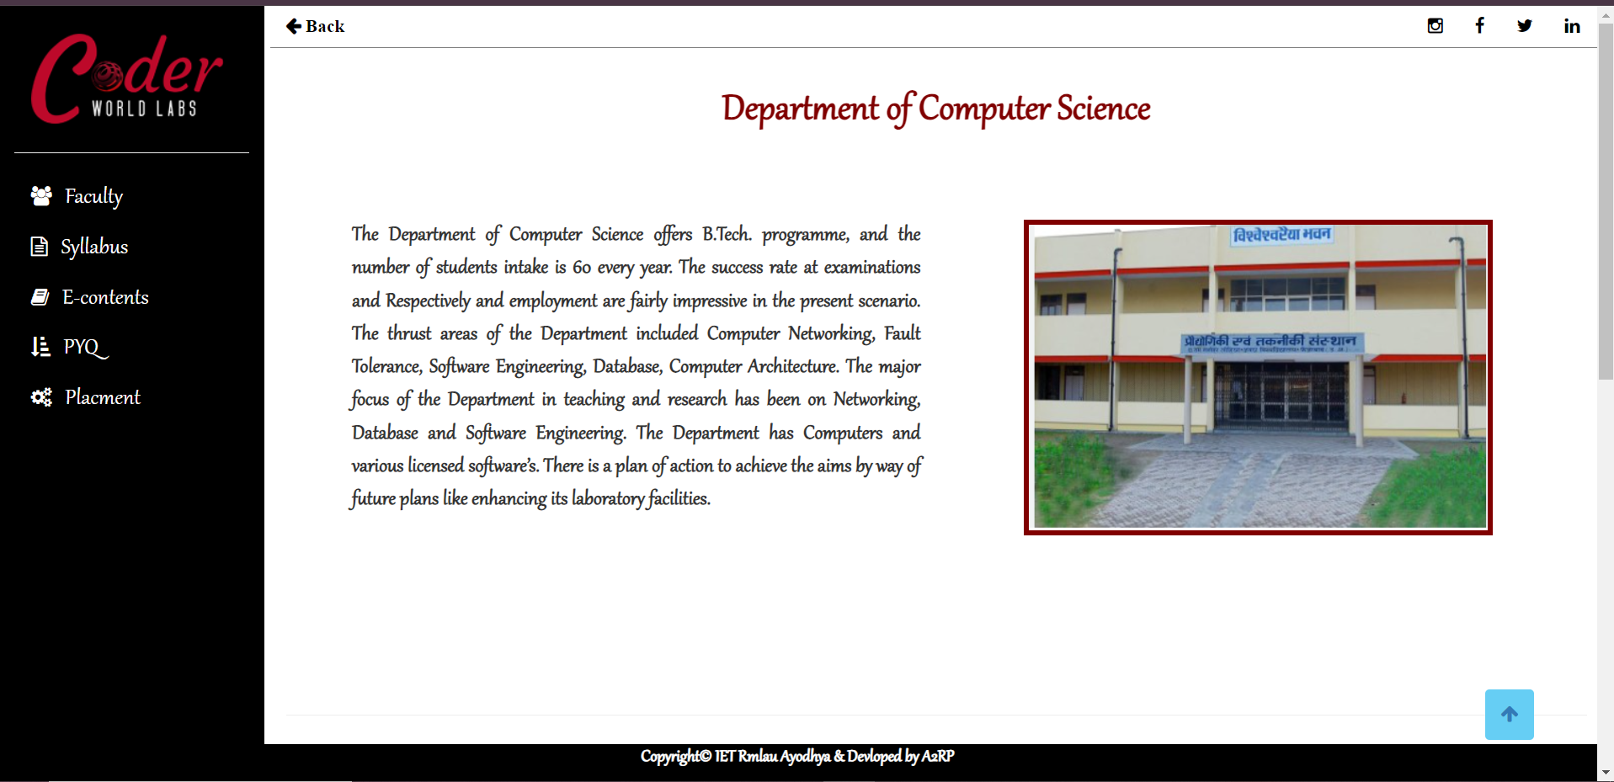

(iii) Syllabus,e-Contents or PYQ:

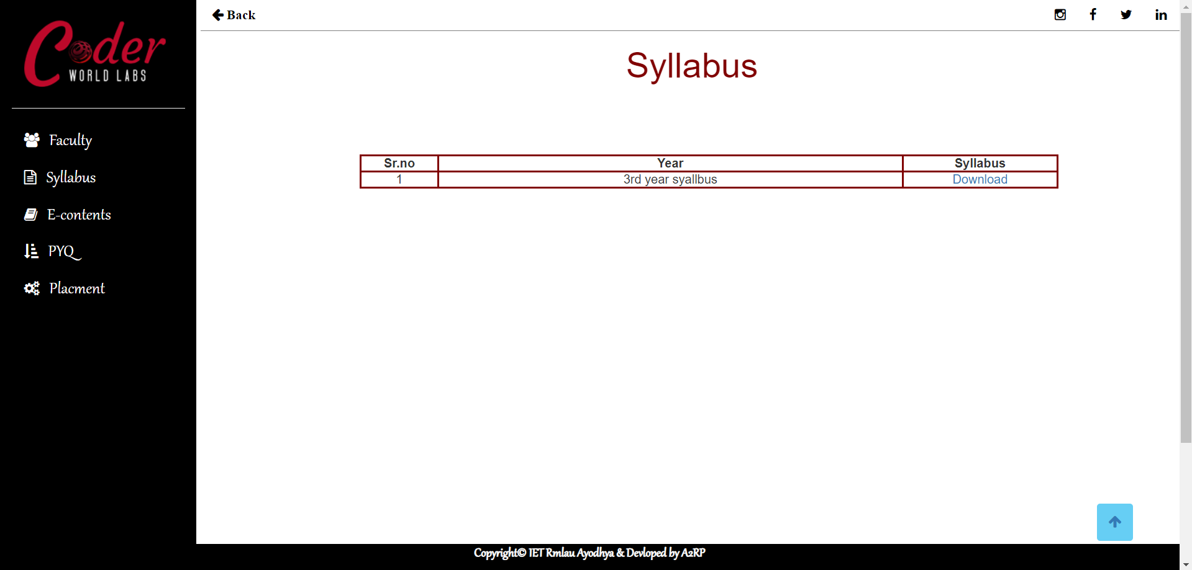

C. Login Window:

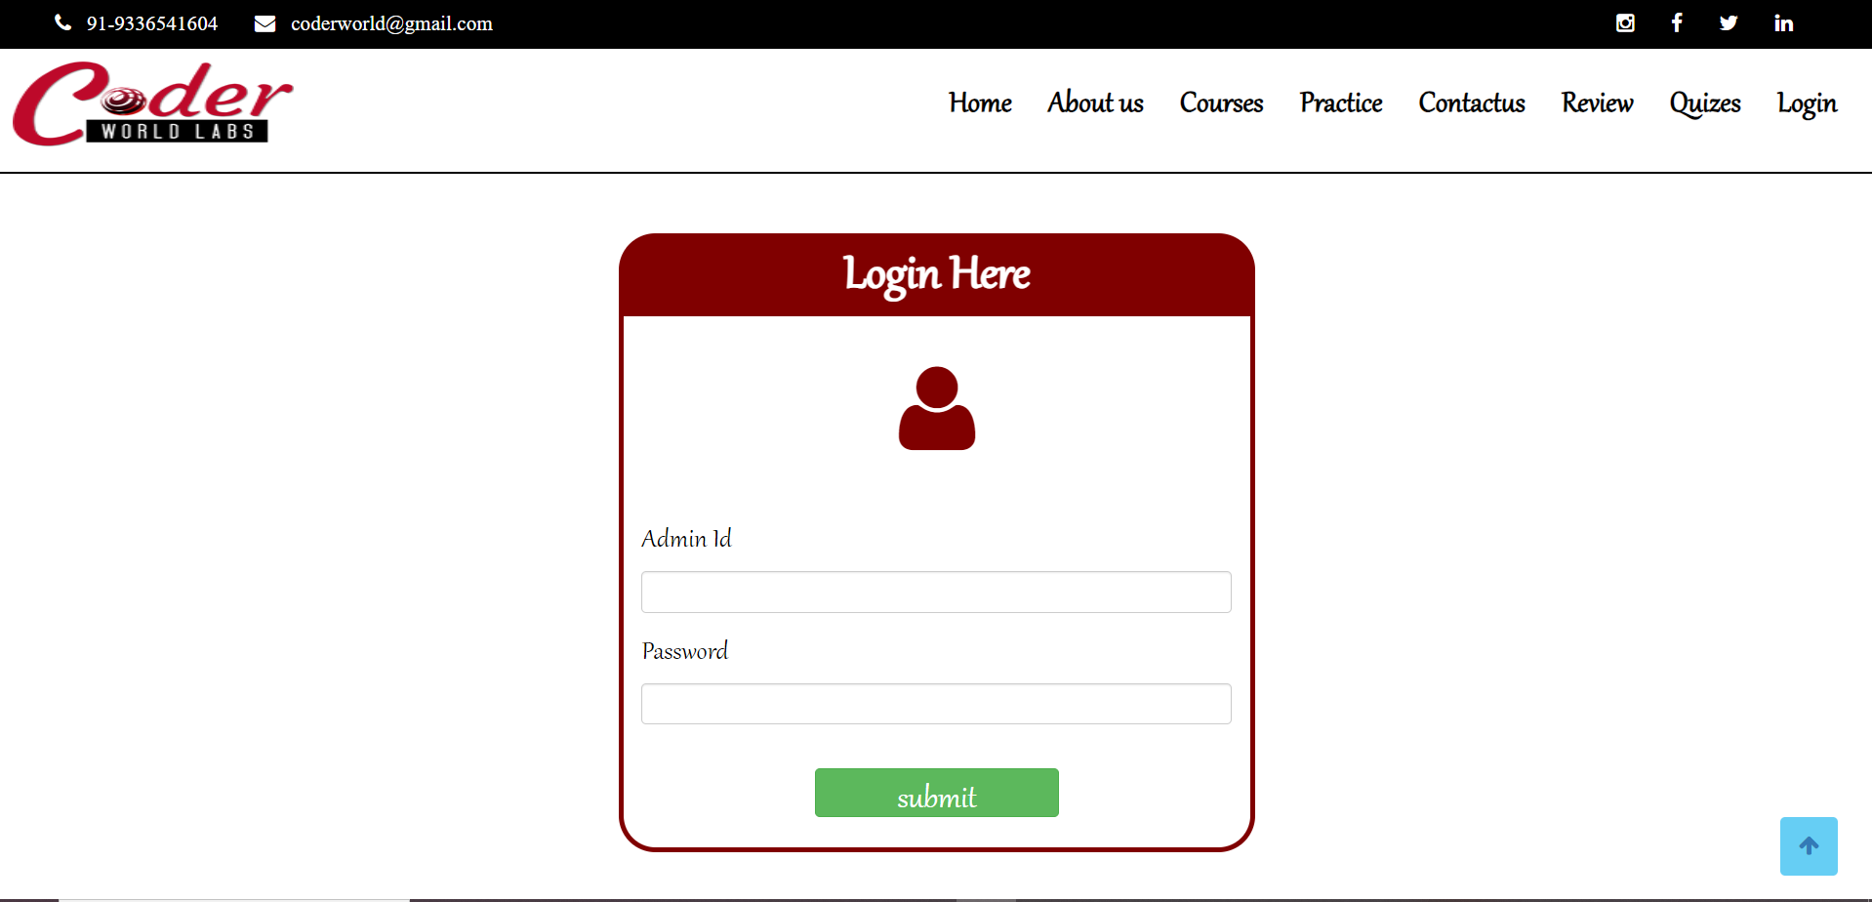

Context Diagram

Web Application
Data Base

Server

Data Flow Diagram

Login
Logout
Add Result
Add Quiz
Add News
Add Syllabus / E-contents
View Result
Placement
Join Quiz
Discuss Problem
ADMIN
USER

Database tables

Login User/ Admin:

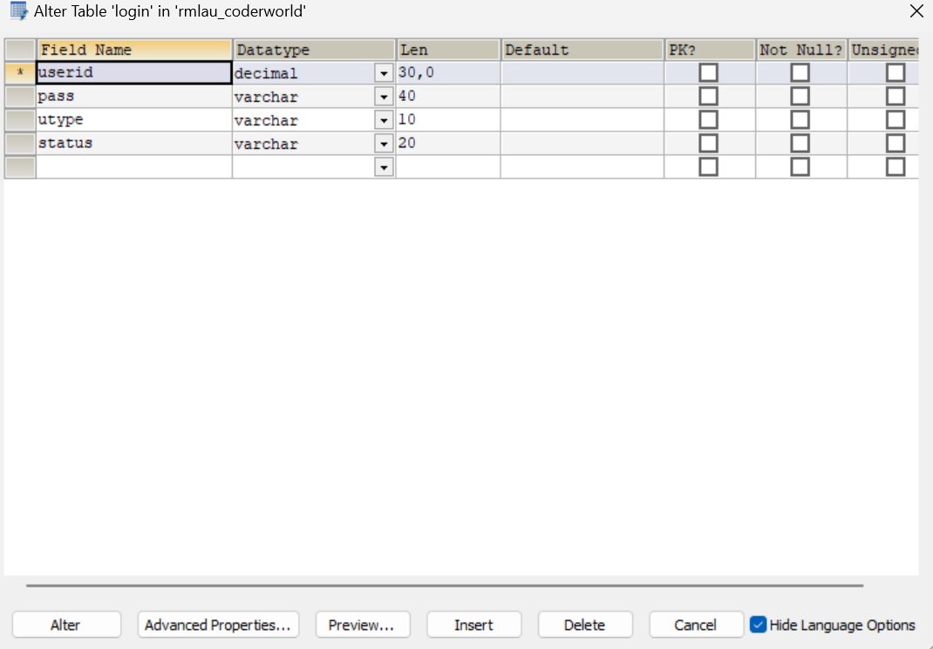

Placement :

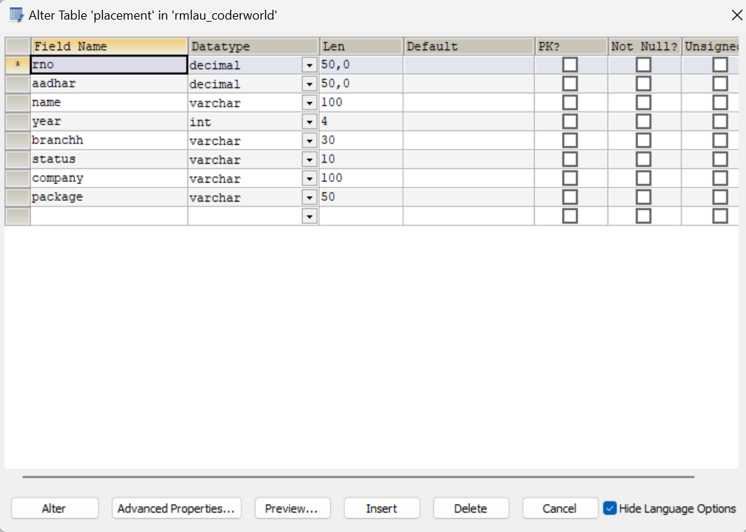

Result:

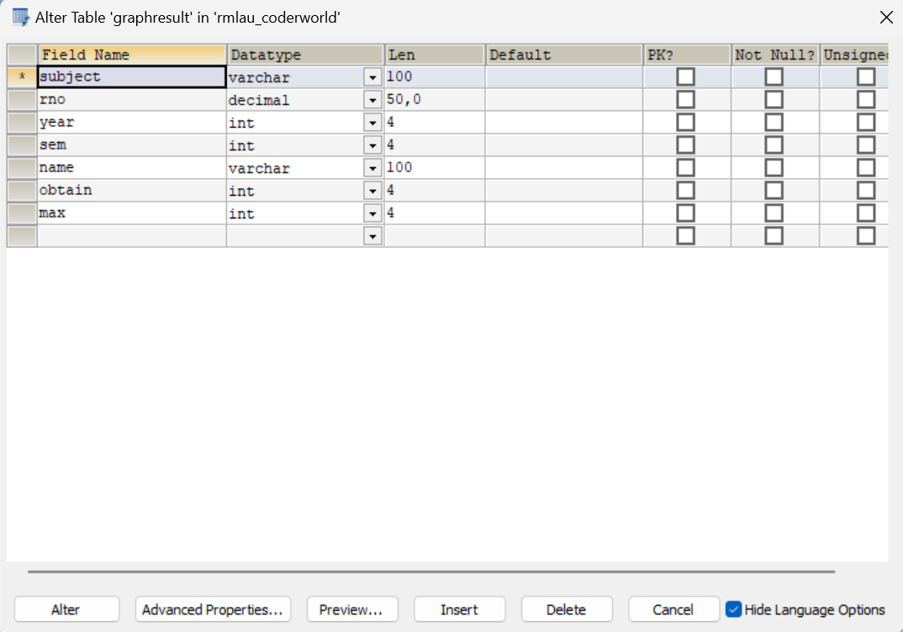

Quiz :

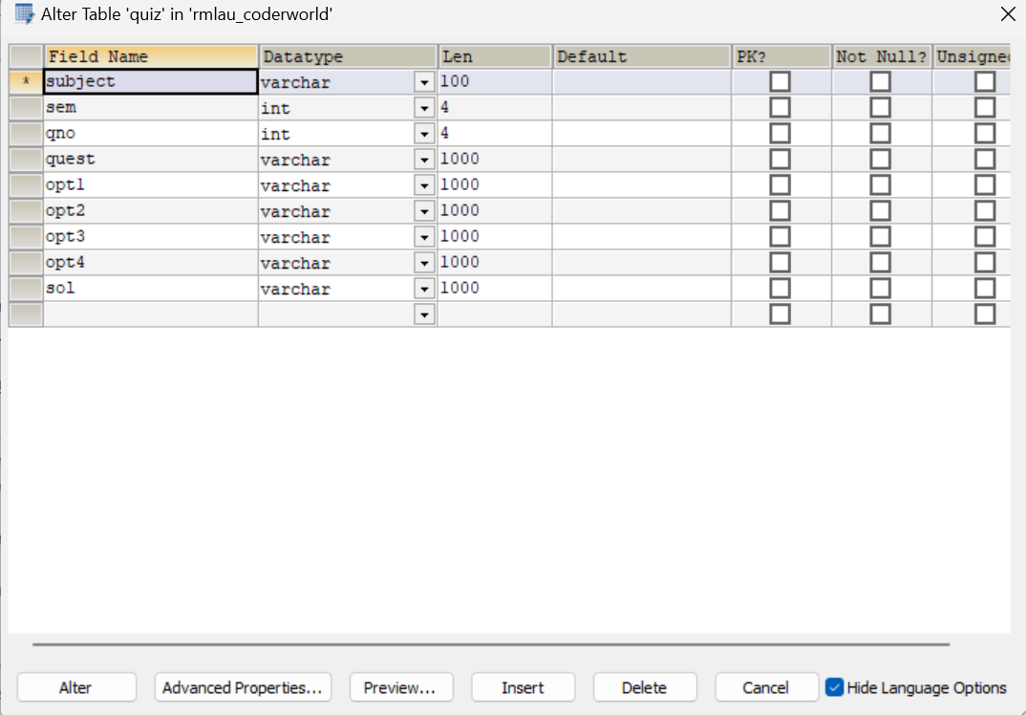

Tools/Platforms & Software

Platforms: | Windows10/Linux
For Application Development: | JDK1.8, NetBeans 8.2
Database Application: | My SQL

Hardware Requirement

- Pentium IV Processor
- 512 MB RAM
- 40 GB HDD
- Color Monitor
- Keyboard, Mouse

Proposed enhancement

The system is designed keeping in mind the current requirements of the
Rmlau Gyansthal. However some aspects were not considered and system can easily changing where shop requirements are changed.
Some of the enhancements can be:
- System can be design in GUI environment.
- System can be design to work without manpower by using Scratch.
- The system can be made flexible so that new modules can be added at any given time.
- In future system can be construct the modules of extract Information More efficiently, Semester Results, Contests can be developed.

Abbreviations
After we have completed the project we are sure that problem in the existing system would overcome. “Rmlau Gyansthal” process has been computerized reduced human error and to increase the efficiency. The main focus of this project is to lessen human efforts and study of students. The maintenance of record is made efficient, as all the records are stored in the database through which the data can be retrieved easily. The navigation control is provided in all form to navigate through large amount of records. Our main aim of the project is to provide correct E-content , details to Students of the University at any time any place.
The problem which exited in earlier system, have been removed to large extent. The Digitalization of the “Rmlau Gyansthal.” will not only improve the efficiency but will also reduce human stress thereby indirectly improving human resources.

References & Bibliography
Material referred for the development of this “Rmlau Gyansthal” is as follows.
Bibliography:
Books referred during project development:
- Complete Reference Java 8. By Mr. Herbert Schildt.
- JAVA 2 Black Book By Mr. Steven Holzner.
- Software Engineering By Mrs. Sharada patil.

Website Reference:
- www.javaworld.com
- www.kashipara.com
- www.tutorialspoint.com
- www.m.youtube.com

